Microdermabrasion
This two-part system immediately fights fine lines, reduces the appearance of pores, and creates noticeably softer, smoother feeling skin with a healthy, more radiant-looking glow.
Step 1: Refine -Key exfoliating crystals immediately energise skin and reveal more radiant, healthy-looking skin.
Step 2: Pore Minimizer - Reduces the appearance of pores and immediately improves skin texture, leaving skin feeling nourished and relieved of stress while visibly improving skin clarity.
Oil- and fragrance-free.
Clinically tested for skin irritancy and allergy.
Hypoallergenic. Non-comedogenic (will not clog pores)
key notes:
DO'S; use twice a week, saying to your customer use on your 'w' day is a good reminder weekend and wednesday.
-use plenty of water when using it
- do cleanse first
- demonstrate on clients hand
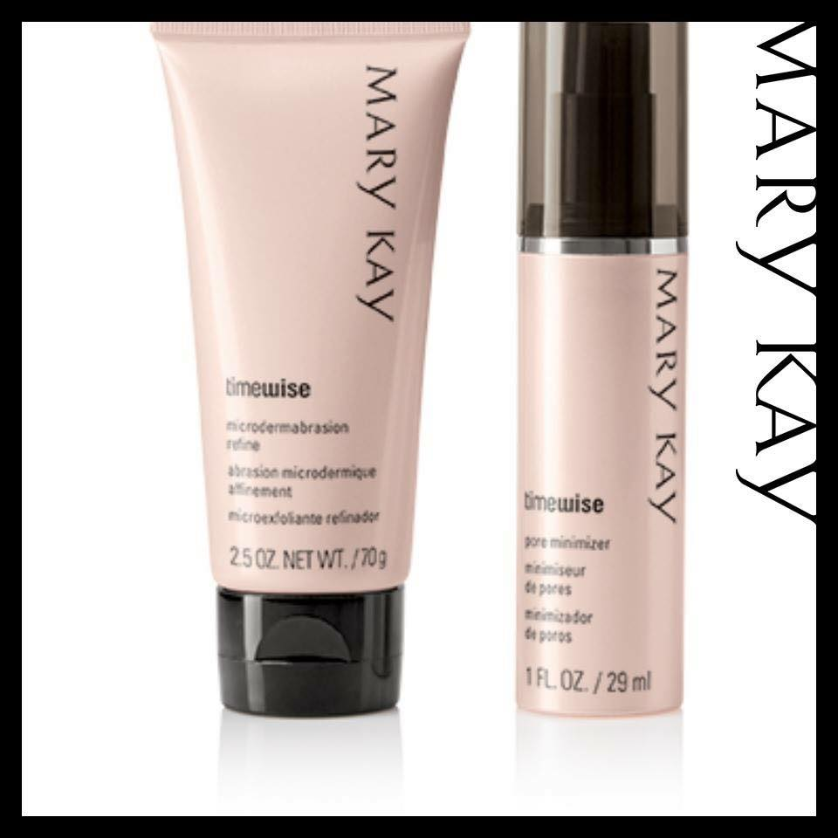
DON'T- use on broken skin
-use two days in a row

Nicole Maile Leave 4 days in between use. Amd don't use ur night cream or day cream with it just moisturiser. Xx
Like · Reply · 12 hrs
Melinda Hollis Why don't you use a day cream or night cream after it?
Like · Reply · 8 hrs
Nicole Maile Not sure why something that belinda told me awhile go when explaining how to use then. May be to much of an over load!x
Belinda Butler It's recommended that you don't use the night solution immediately after microdermabrasion because the skin may be a little sensitive and the night solution penetrates deep into the layers of the skin. If you've used it at night You can use the day solution the following morning just steer clear of night solution immediately after

Translucent Powder
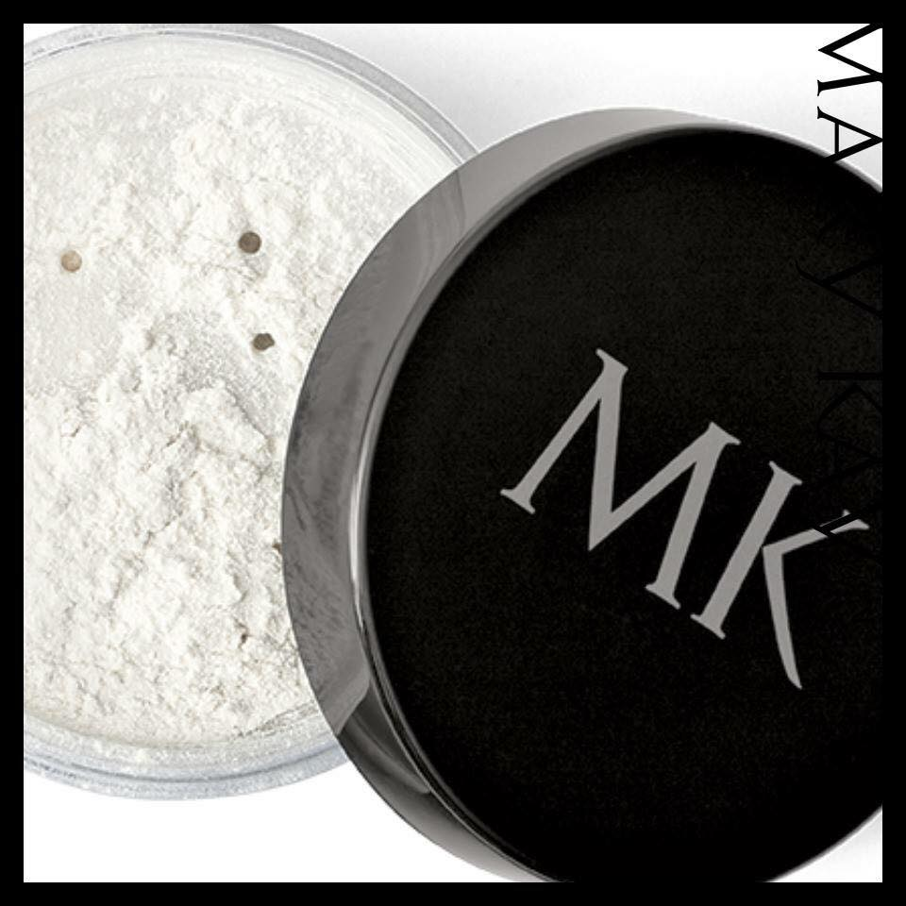
You, Nicole Maile, Gill Barkes and 2 others

Comments
Belinda Butler This is one of my favourites. I'm a CC cream lover and apply this translucent powder over the top to take down the shine and to make it longer wearing xx
Like · Reply · 14 hrs
Jane Mott I little over lipstick holds it in place longer, then apply 2nd layer of lip colour over top. (extra staying power when lip liner used first) x
Like · Reply · 14 hrs
Charlotte Crouch One of my favorite products! translucent powder! Here is why;
1- sets foundation, if you like the dry feel apply this after your foundation all over paying special attention to the under eye area and the eye lid. A set eyelid helps eye-shadow application and blending. A properly set under eye area prevents creasing.
2- matifys any lipstick making it super long lasting and transfer proof
3- soaks up oil prone skin
4- doesn't change the colour of your foundation!

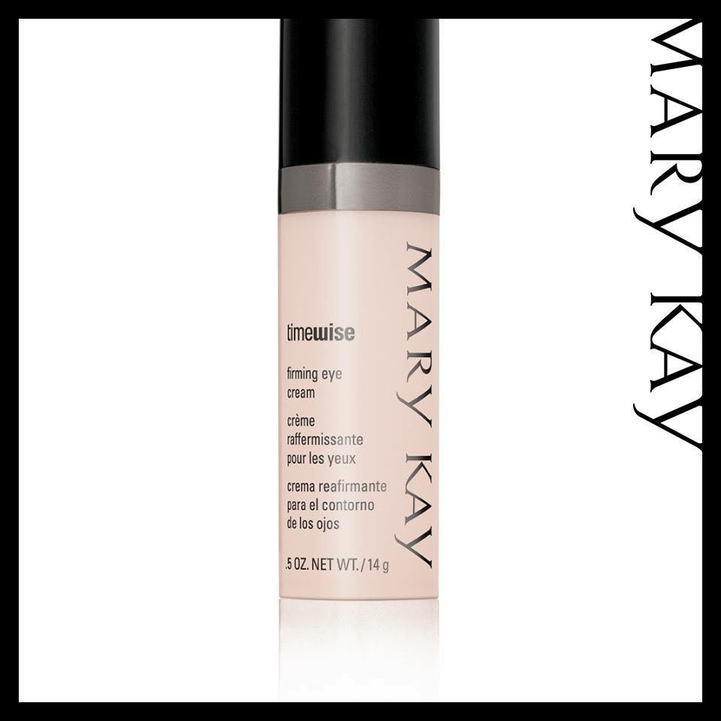
Firming Eye Cream
Did you know that your eye area is the thinnest area on your face? Its where aging starts showing first. Fight it with this amazing eye cream!
​This luxuriously rich eye cream is so advanced it improves firmness, brightens and provides intense moisturisation, plus minimises the appearance of fine lines and wrinkles.
-Ophthalmologist-tested.
-Suitable for all skin types.
-Hypoallergenic.
-Suitable for contact lens wearers
£29

TimeWise® Moisture Renewing Gel Mask

I have combination skin and occasional eczema flare ups and this product it an absolute godsend. ..also has great results on Acne Roscea will calm, soothe also and reduce redness - improvements will be seen after one application. (see before and after photo attached)
10 benefits from one product.
It’s your multitasking miracle that breathes new life into tired, sluggish, stressed skin. TimeWise® Moisture Renewing Gel Mask instantly hydrates and locks in moisture. Skin appears less stressed and feels purified, nourished, calmed, firmer, smoother and softer. Also helps minimise the appearance of fine lines, wrinkles and pores. It features an aromatic scent of botanical extracts including chamomile, rosewood and lavandin. And it is oil- and fragrance-free, non-comedogenic
I apply it as a night cream and leave it on overnight.Use 2-3 times per week.
How It Works
TimeWise® Moisture Renewing Gel Mask is a superhydrating, age-fighting formula for skin that feels nourished, pampered, firmer and smoother. The luxurious rich gel glides on effortlessly, infusing skin with moisture as it increases its resilience. Skin appears less stressed, plus the appearance of pores is reduced. Its aromatic blend of botanical extracts, including chamomile, leaves you with a sense of well-being.
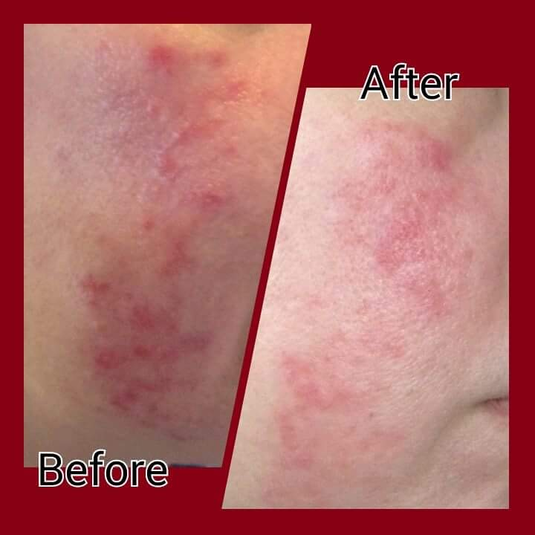
Love, love, love this product. ..if you've not tried you are missing out.

